**Instructor Signature: ________________________**

**Date: ________________________**

Introduction

One of many cool things that you can do with your Pi is take pictures and make movies. An accessory that we bundle with your Starter Kit is the 2.1 version Pi Camera Module. You can also purchase a night-vision and 8MB “high-definition” camera module for your applications. There are longer ribbon cables that can be found if you need more length as well as camera cases for protection. The Broadcom device installed on your Pi similar to other embedded devices that have cameras on them use the standard CSI or Camera Serial Interface protocol so that you can take pictures and make videos.

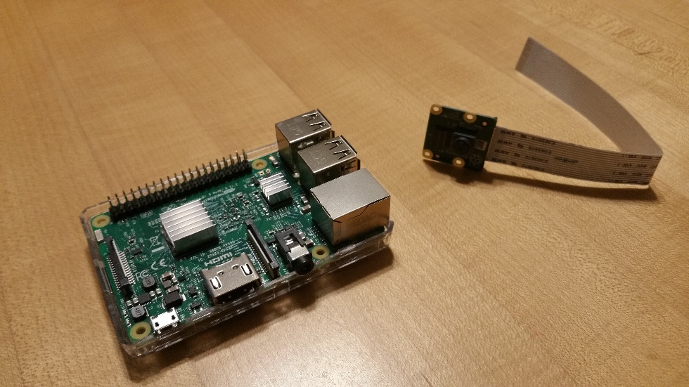

Besides using the Pi Camera module there are also projects that can be built around using a USB WebCam. When using these modules an external power supply must be used with the webcam. There is not enough power from the Pi units USB connectors to power both the Pi and the external WebCam. Typical applications include home security, pet watching, and gaming.

**Outcomes:**

**As a result of this activity you will be able to –**

1. Demonstrate installing the Pi camera module correctly for use.
2. Utilize Raspistill and Raspivid to take pictures and make movies.
3. Have a working knowledge of the file format and applications used to view files.

**Equipment and Supplies:**

RPi Unit

PC for Remote Access and Internet

Raspberry Pi Camera Module

Optional: USB WebCam with Powered USB Hub

Procedure I -- Installing Pi Camera Module

1. Install the micro SD Card that contains the operating system and make sure the card is aligned as you slide it into the slot.
2. You may plug the power supply cable into the Pi; but do not plug it into the wall yet until the camera module is installed.
3. Open up the Pi Case to gain access to the connector for the Pi Camera Module.
4. Carefully open the serial connector’s locking mechanism for the camera and align the ribbon cable where the metal tabs are facing towards the HDMI connector and slide the ribbon cable into the connector. Slide the locking mechanism down to lock the cable into place. You should see some of the metal connectors from the ribbon cable (Refer to Figure 1)

|  |
| --- |
|  |

Figure 1

1. To test the camera module for correct installation, open the terminal and type the following command: ***$raspistill –o test.jpg***



Note: Raspistill is a powerful program for taking pictures, the –o will open the camera module to take the picture; test.jpg is the file name given to the test picture. The file will be saved in the current user directory. By default that is the “pi” folder. Refer to Figure 2.

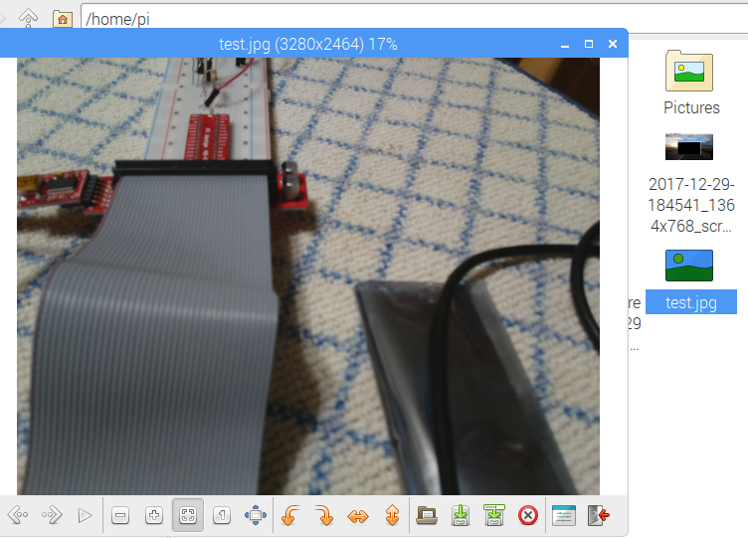Figure 2

1. Check the current user directory for the file test.jpg and if the camera does not take a still shot then type ***$sudo poweroff*** and terminate the remote session. Here is a list of items to troubleshoot:
   1. Check the connection of the camera module and make sure it is connected correctly and seated in the connector.
   2. Power the Pi back up and make sure the camera module is enabled in the configuration menu. See the notes for using ***$sudo raspi-config*** command to enter the preferences menu through the terminal. Sometimes in the remote session you will not be able to enter the preferences menu through the GUI.

Procedure II – Making Videos with Pi Camera Module

To make a test video type ***$raspivid –t 10000 –o video.h264*** This program is just as powerful as raspistill and will create a 10 second video using the camera module.



To play the video back connect the Pi using the HDMI cable to a monitor and type ***$omxplayer video.h264***

Note: You will not be able to play the video via remote access; connect the Pi back up to the monitor with the HDMI cable.

The options for omxplayer are listed by typing in at the prompt $omxplayer –h which will give you a list of controls to watch the video. The terminal must be active for the keys to register (you cannot have clicked your mouse into the desktop area for the keys to work.

**WARNING**

The raspberry pi has limited power to the usb connectors (web cams and pi camera module require 200 milli-amps to 250 milli-amps). If you are running on the wi-fi adapter there will be less power available also to the usbs. the webcam led may be on but there may be issues with transmission loss. use a powered usb hub.

Alternate Procedures if you have a portable WebCam

Procedure III -- Setting up the USB WebCam

1. Connect the powered USB Hub into the USB Connector of the Pi (just pick one). Plug the USB WebCam into the powered USB Hub and then power up the hub with its power supply.
2. Open a terminal session and at the ~$ prompt type in *lsusb*  This utility will provide a list of information for the WebCam (C270) connected and the USB Hub (SMC9514 Hub). Your list will look similar to Figure 3. What does this mean? That Linux some level of support for drivers for this device. If you do not see anything then have to find Linux drivers from the WebCam manufacturer to use the device.

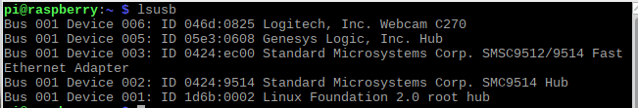

Figure 3

1. The following commands in the terminal will show you the modes, output, and support:
   1. 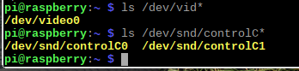lsusb –v | less
   2. lsmod | grep video
   3. ls /dev/vid*
   4. ls /dev/snd/controlC*

Try these four commands and take a screen shot and compare it to the picture above.

Procedure V – Setting up utilities and drivers to capture pictures and videos

1. Install LUVCVIEW software by using ***$sudo apt-get install luvcview***
2. In the desktop environment within the terminal type luvcview to start the application.
   1. It may take a few moments but a window will open to show the view of the active webcam. The webcam LED will be on and the view maybe a bit choppy but you should see a view of the current video. It is not capturing it but viewing. An additional application such as SimpleCV that can work with Python Code will allow you to write the video to a file and store it.

We will explore more with the camera module once we start programming the Pi with Python.

Demonstrate:

1. Create a compressed folder that includes the picture and video you took with your camera. Submit this as your assignment with your lab synopsis questions.

**Lab Synopsis Questions:**

1. Briefly describe what you did in this lab (Concisely document your process):
2. What equipment was used? *Example:* Extech Model EX212 Handheld DMM
3. What observations and/or data was collected for this lab/project?
4. Document any difficulties you had when performing the lab:
5. What questions do you still have after completing this lab?
6. Document any ah ha moments or unexpected results that you observed in the lab:
7. Document any Tech Tips that you experienced in the reading, lectures, and/or lab: *Example:* Be sure to open the circuit and insert the meter into the current path when measuring current. Failure to do so will result in a blown fuse in the meter.

Please do not leave questions 6 and 7 blank. Think about your experiences with the lab or the preparation up to the lab to respond to these…reflection is always a way of improving yourself for next experience.